Drawing with the Library of Functions
By ( )
Student’s Name
Professor’s Name
Course
Date

Drawing with the Library of Functions.
Definitions for more understandings
 | Vertical | Horizontal
Scale | a | b
Shift | d | c
 | Acts normally | Acts inversely

Constant Function: y = c
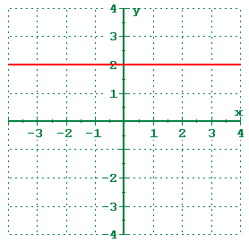
Linear Function: y = x
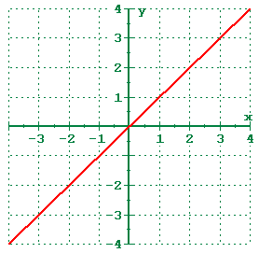
Quadratic Function: y = x²
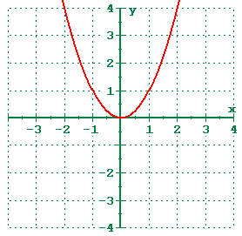
Cubic Function: y = x³
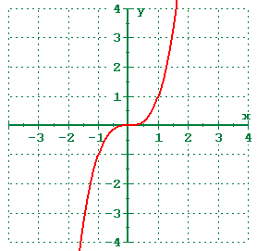
Absolute Value Function: y = |x|
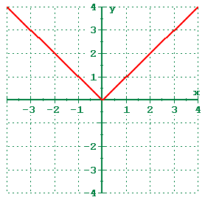
Square Root Function: y = sqrt(x)
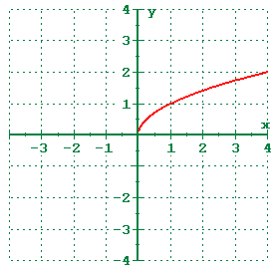

Solutions

- $f\left(x\right)=x \{0<x<2\}$
Solution

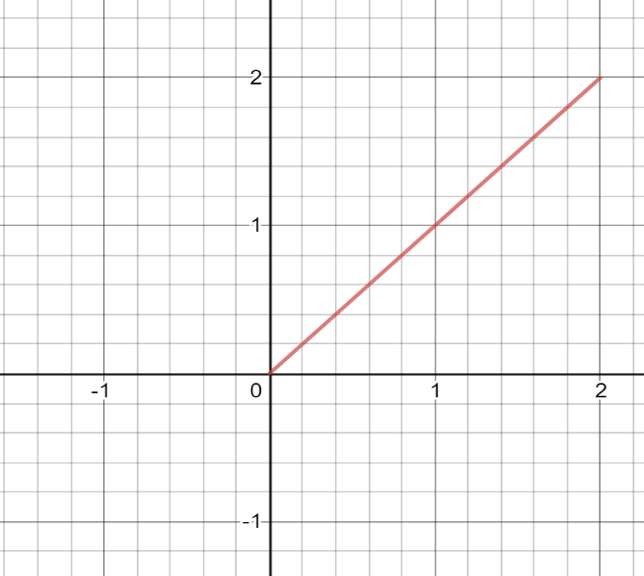
This is the original graph generated by the equation above.

Transformations
Having equation
y=af (b (x-c)) +d
Y = y coordinate
a = slope
X = x coordinate
d = y intercept
Domain of x, ( 0 < x <2)
(0,2)
Range of x, (0 <f(x)< 2 )
(0,2)
X - Axis interception points of x, 0 < x <2 ; None
y - Axis interception points of x, 0 < x <2 ; None

Taking a= -1, b= 0.5, c= 0 and d=0
We get

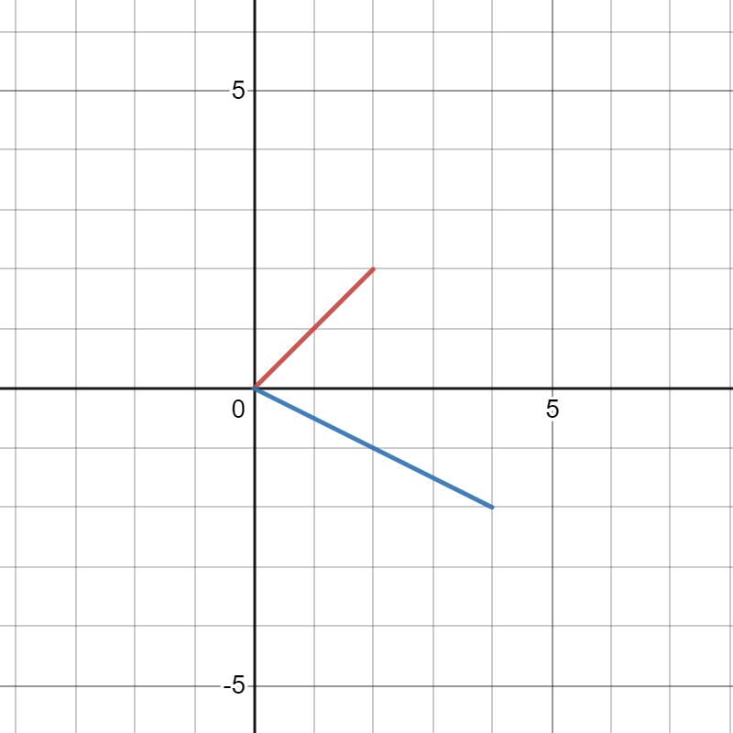

The new graph is reflected on the opposite side where (A = -1) then having (b =0.5) the image is stretched twice and having (c = 0 and d = 0). The line starts and ends the same point.
On the same image letting
x=f(y)
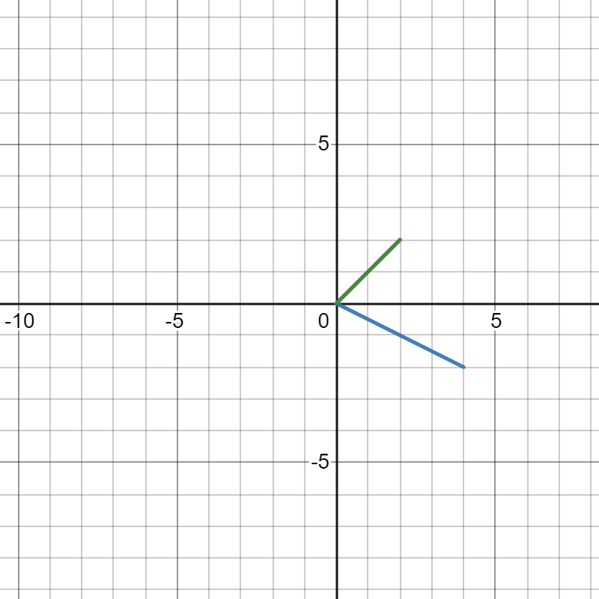

The graph image will be on the same position with the original one. Having no transformations.
The symmetric will be reflected 180 degrees
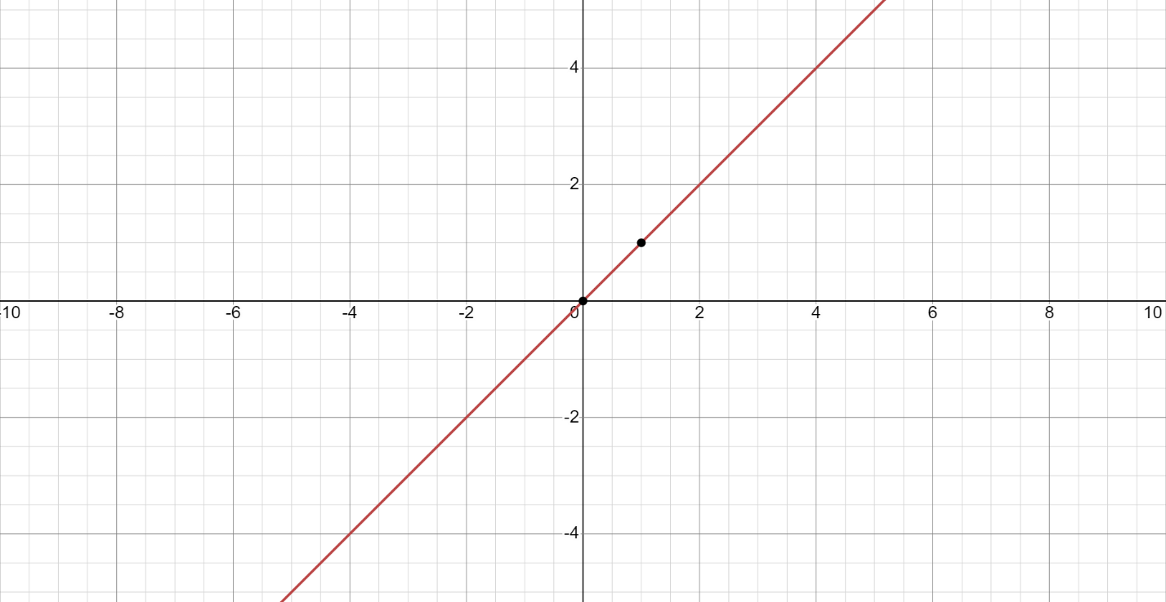

- f(x)=x^{2}{0<x<2}
Solution

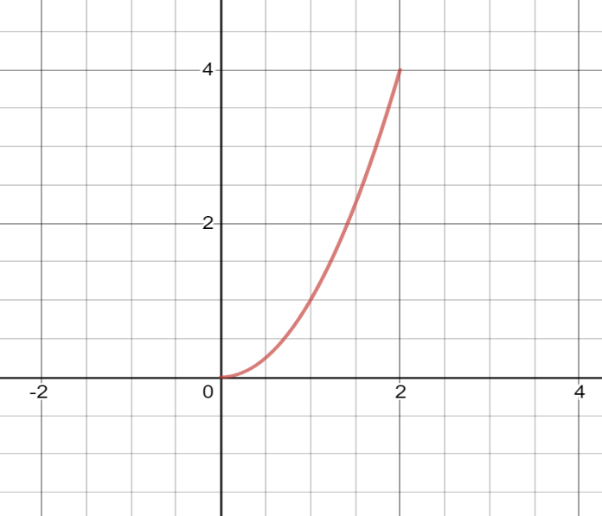
This is the original graph generated by the equation above.

Transformations

Having equation
y=af (b (x-c)) +d
Taking
a=-1
b=1
c=0
d=0
x=f(y)
Domain of x², ( 0 < x <2)
(0,2)
Range of x², (0 <f(x)< 4 )
(0,4)
X - Axis interception points of x² , 0 < x <2 ; None
y - Axis interception points of x² , 0 < x <2 ; None

We get

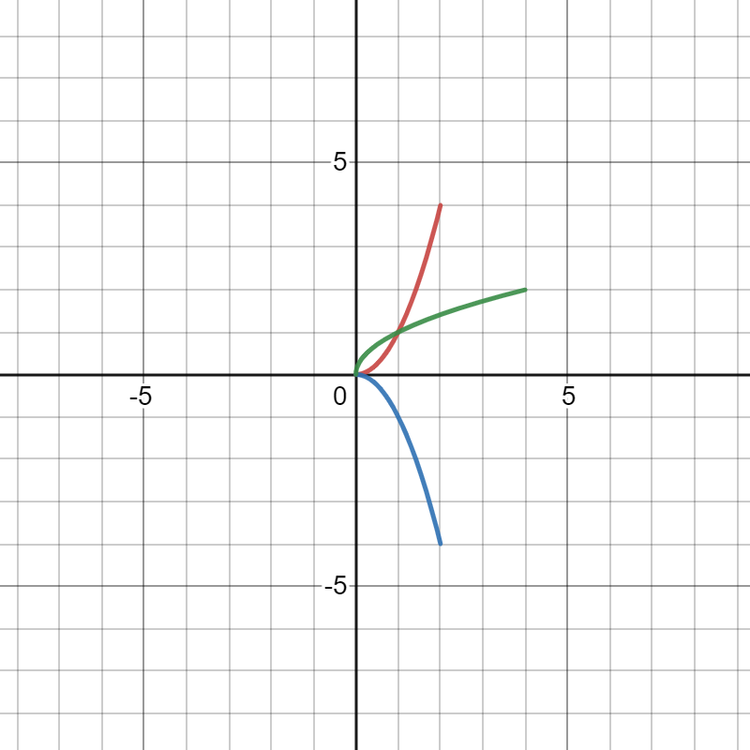
The green graph image is the transformation when x=f(y).it is the same stretched the same distance as the original image but it is generated on the opposite direction.
Having the (A = -1 and B = 1) the graph image is reflected on the opposite direction having the same but opposite co-ordinates. Having (c= 0 and d =0) the image starts the same point as the original one.
The symmetric of the graph will have a rotation of 90 degrees on the left side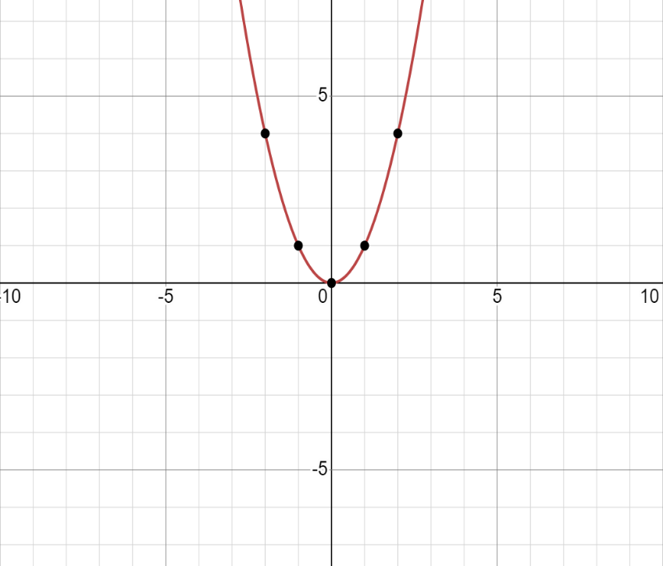

- f(x)=x^{3}{0<x<2}

Solution

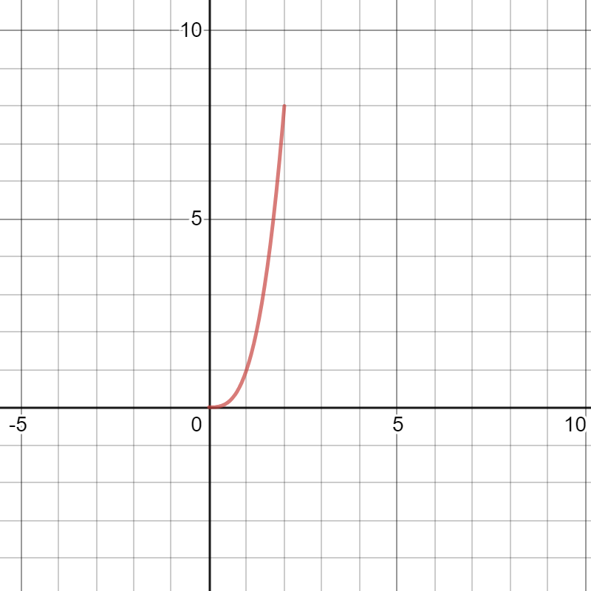
This is the original graph generated by the equation above.

Transformations
Having
y=af (b (x-c)) +d
a=-1
b=1
c=0
d=0
x=f(y)
Domain of x³, ( 0 < x <2)
(0,2)
Range of x³, (0 <f(x)< 8 )
(0,8)
X - Axis interception points of x³ , 0 < x <2 ; None
y - Axis interception points of x³ , 0 < x <2 ; None

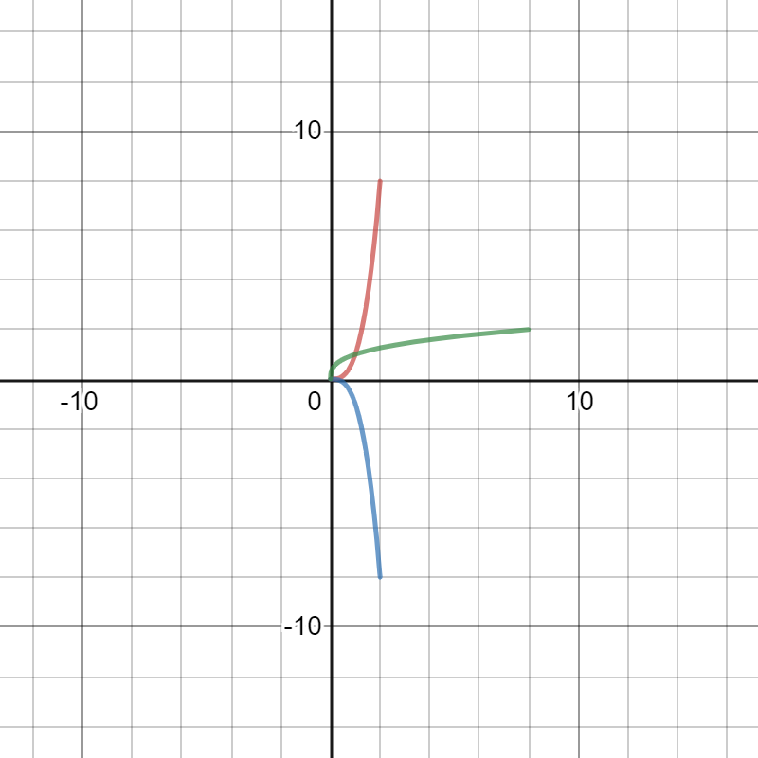
The green graph image is the transformation when x=f(y).it is the same stretched the same distance as the original image but it is generated on the opposite direction.
Having the (A = -1 and B = 1) the graph image is reflected on the opposite direction having the same but opposite co-ordinates. Having (c= 0 and d =0) the image starts the same point as the original one.
The symmetric of the graph will be reflected 180 degrees having opposition coordinates
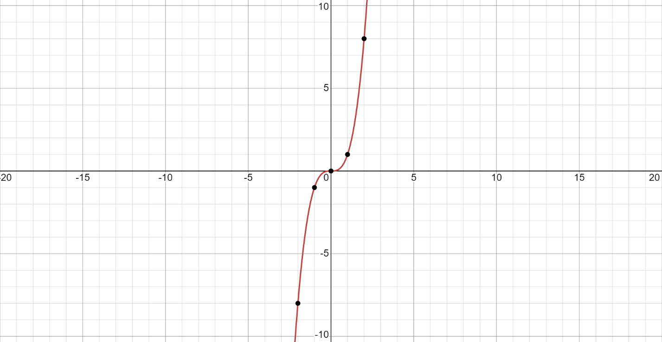

- f(x)=sqrt{x} {0<x<2}
Solution

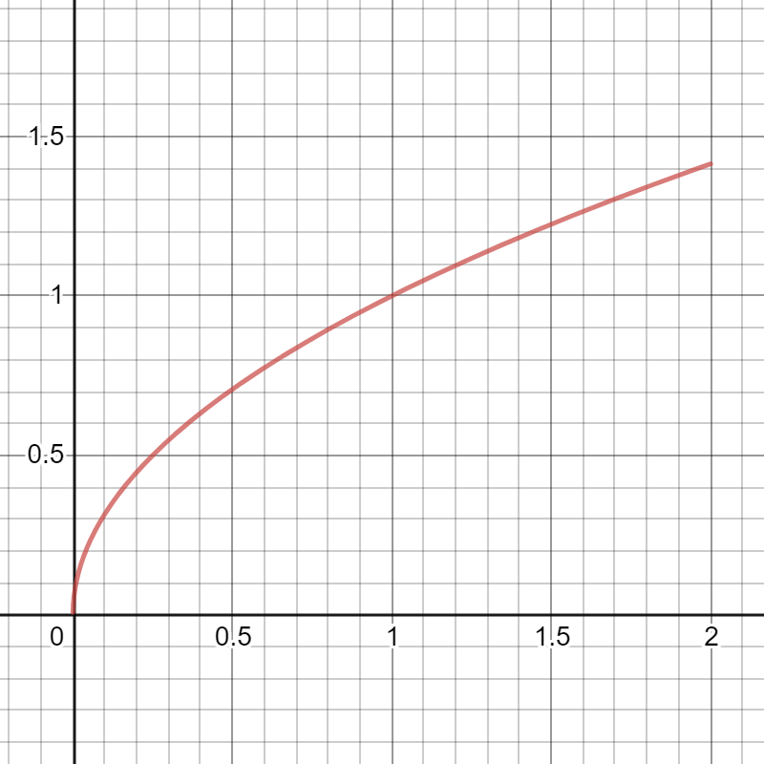
This is the original graph generated by the equation above.

Transformations
Having
y=af (b (x-c)) +d
a=-1
b=0.5
c=0
d=0
Domain of sqrt x, ( 0 < x <2)
(0,2)
Range of sqrt x, (0 <f(x)< 2 )
(0, sqrt 2)
X - Axis interception points of sqrt x , 0 < x <2 ; None
y - Axis interception points of sqrt x , 0 < x <2 ; None
x=f(y)
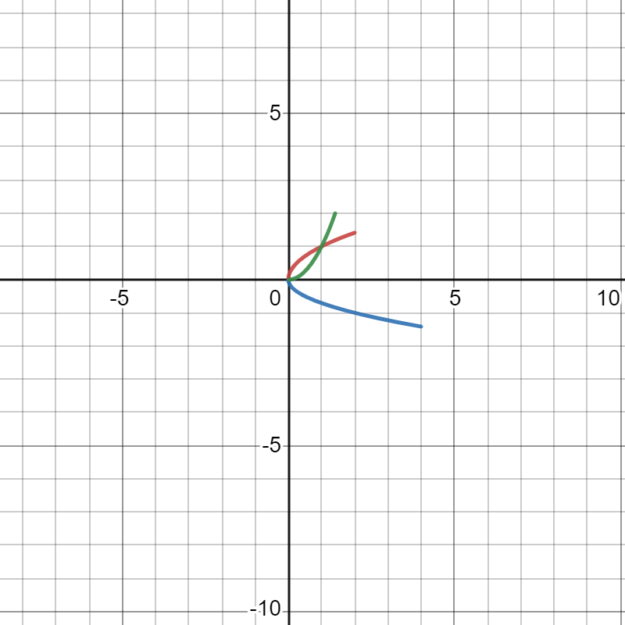
Having (a = -1) the graph image will be reflected 90 degrees on the opposite right side. Having (b = 0.5) the imaged will be stretched twice. Having (c = 0 and d = 0) the image will have the same starting point on both axis.
The green graph image is the transformation when x=f(y).it is the same stretched the same distance as the original image but it is generated on the opposite direction.
The symmetric of the graph will be on the same point as the orginal image
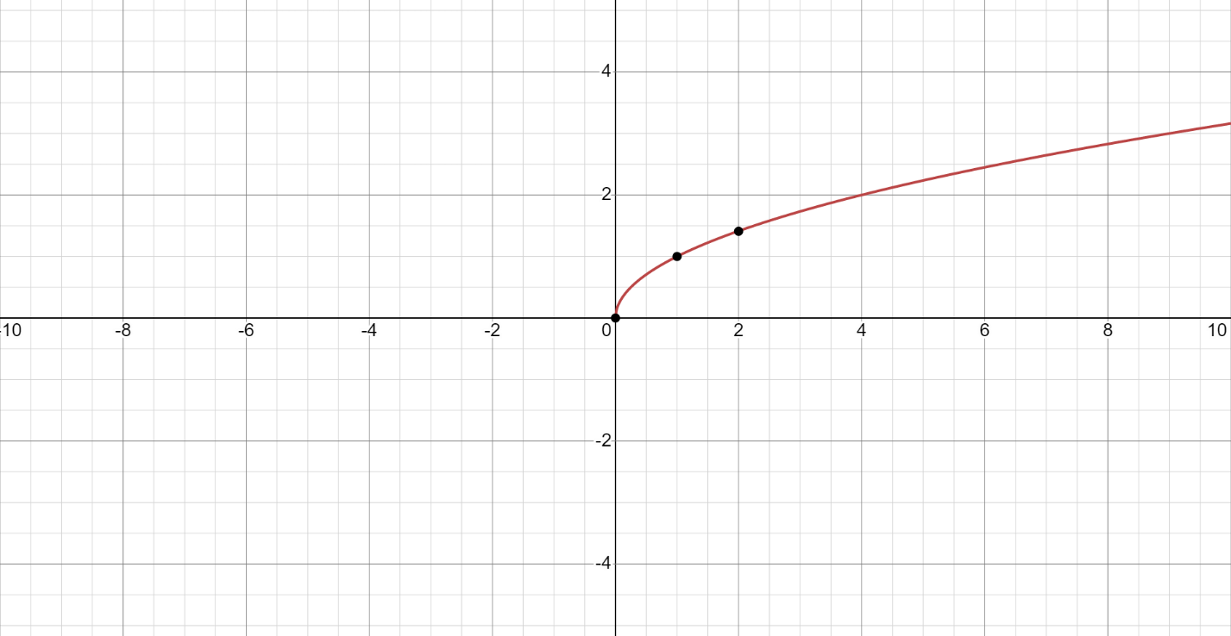

- F(X)=X^{1}/{3} {0<X<2}
Solution
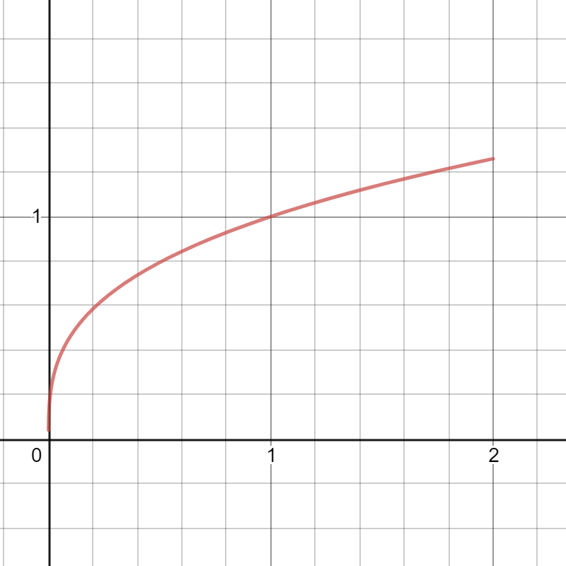
This is the original graph generated by the equation above.

Transformations
Having
y=af (b (x-c)) +d
a=-1
b=2
c=0
Domain of sqrt[3]{x}, ( 0 < x <2)
(0,2)
Range of sqrt[3]{x}, (0 <f(x)< sqrt[3]{2})
(0, sqrt[3]{2})
X - Axis interception points of sqrt[3]{x}, 0 < x <2 ; None
y - Axis interception points of sqrt[3]{x}, 0 < x <2 ; None

x=f(y)

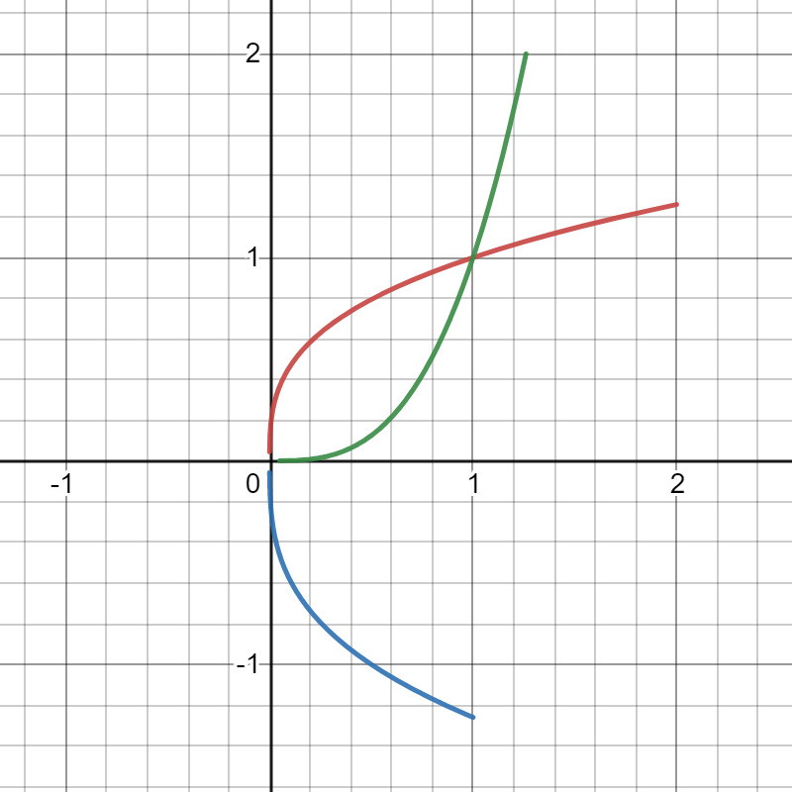

Having (a = -1) the graph image will be reflected 90 degrees on the opposite right side. Having (b =2) the imaged will have to shrink half of the original image. Having (c = 0 and d = 0) the image will have the same starting point on both axis.
The green graph image is the transformation when x=f(y).it is the same stretched the same distance as the original image but it is generated on the opposite direction.
The symmetric of the graph will be reflected 180 degrees from the origin graph
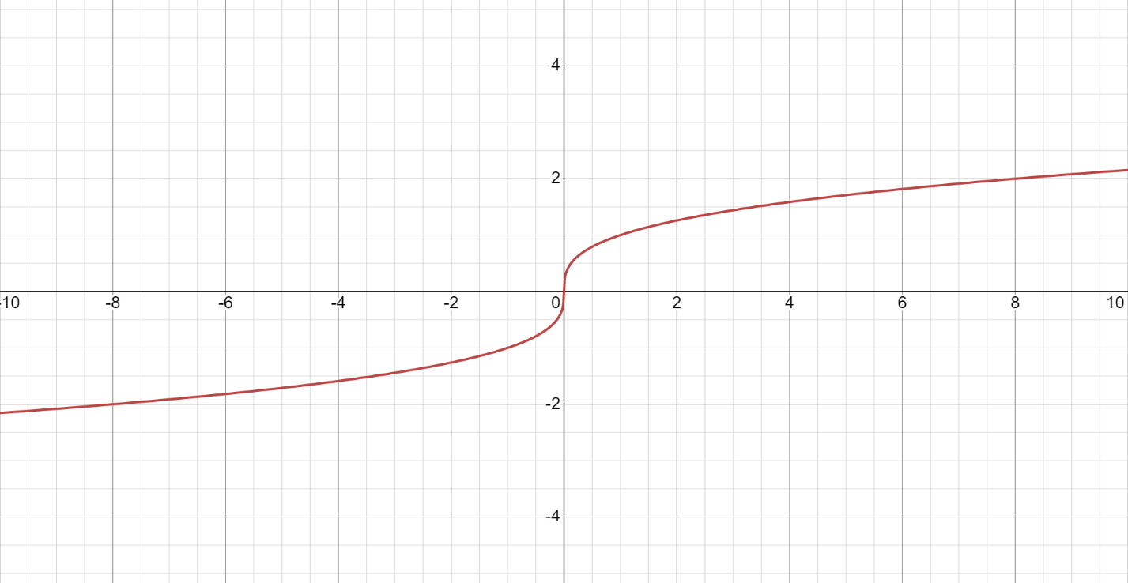

- $f\left(x\right)=\frac{1}{x}$ {0<X<2}

Solution
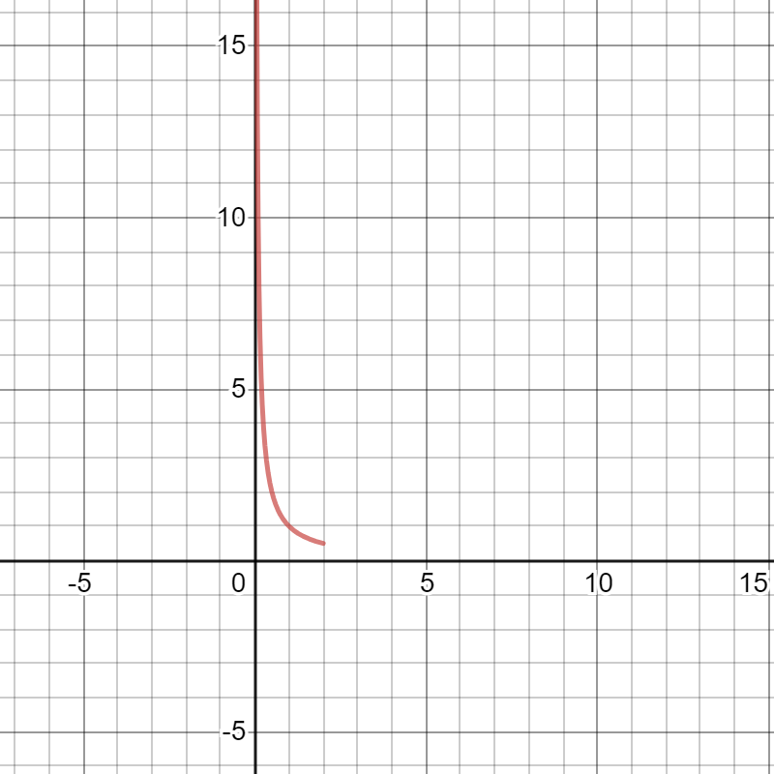
This is the original graph generated by the equation above.

Transformations
Having
Domain of 1/x, (0 < x <2)
(0, 2)
Range of 1/{x}, (0 <f(x) < 1/2)
(1/2, infinity)
X - Axis interception points 1/{x}, 0 < x <2 ; None
y - Axis interception points of 1/{x}, 0 < x <2 ; None

y=af (b (x-c)) +d
a=-1
b=1
c=0
d=0

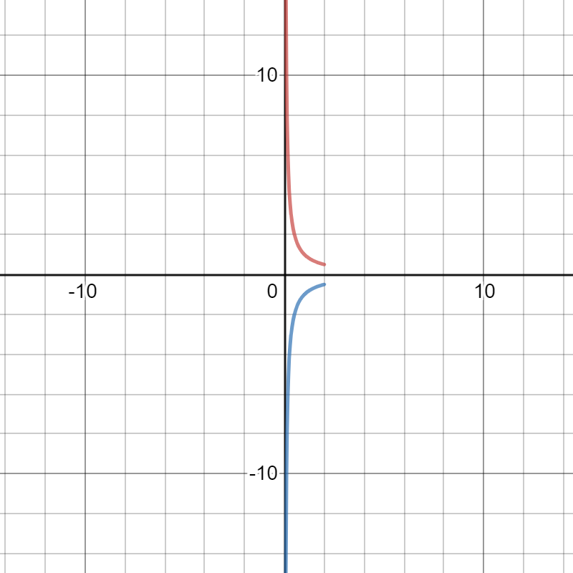
Having (a = -1) the graph image will be reflected 90 degrees on the opposite right side. Having (b =1) the imaged will have no shrinking or stretching. Having (c = 0 and d = 0) the image is reflected on the opposite side having different originally points.

Assuming
x=f(y)

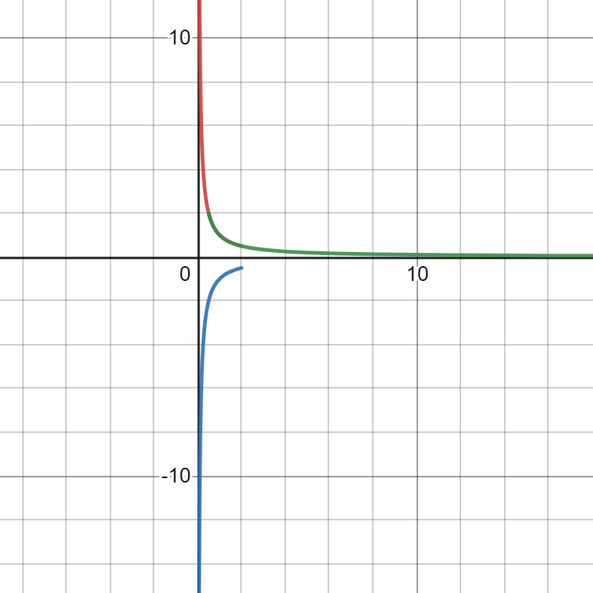
The graph image will be reflected 90 degrees on the right side. Having the same originally points as the original image.
Symmetric of the graph will rotate 180 degrees from the original graph.
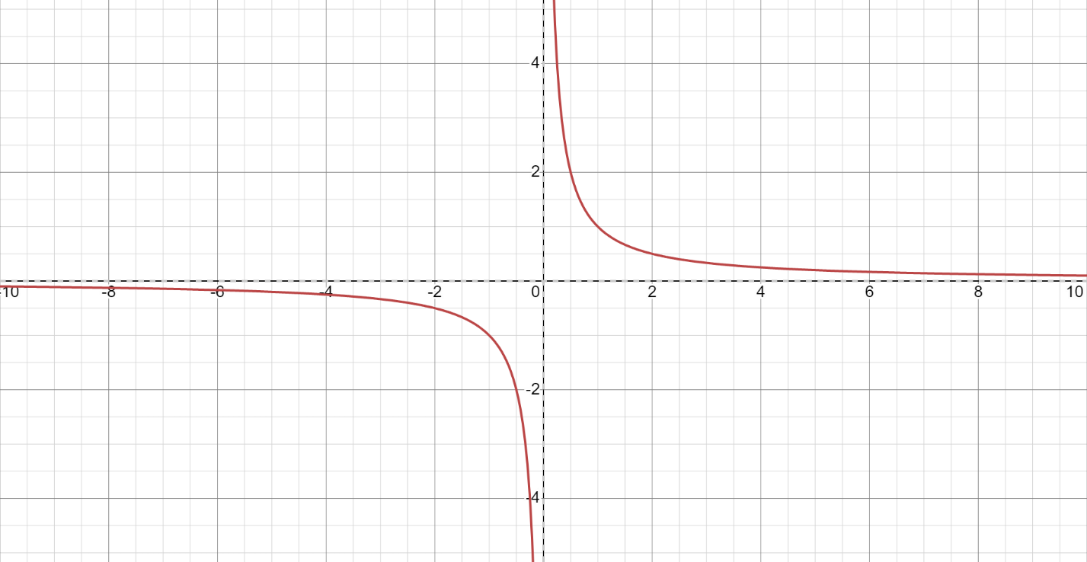

G. f(x) =$\left|x\right|$ {0<x<2}
Solution
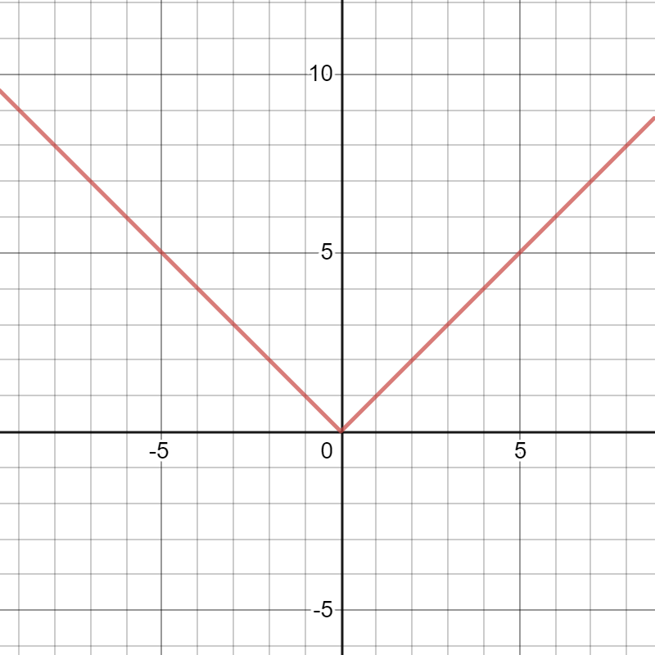
This is the original graph generated by the equation above.
Transformations
Having
F(x) =|x|
y=af (b (x-c)) +d
a=1
c=3.3
d=2.7
F(x) =3|x-c|+d
F(x) =af|x-2|+d
F(x) = - |x-c|+d
F(x) =af |x-c|+7
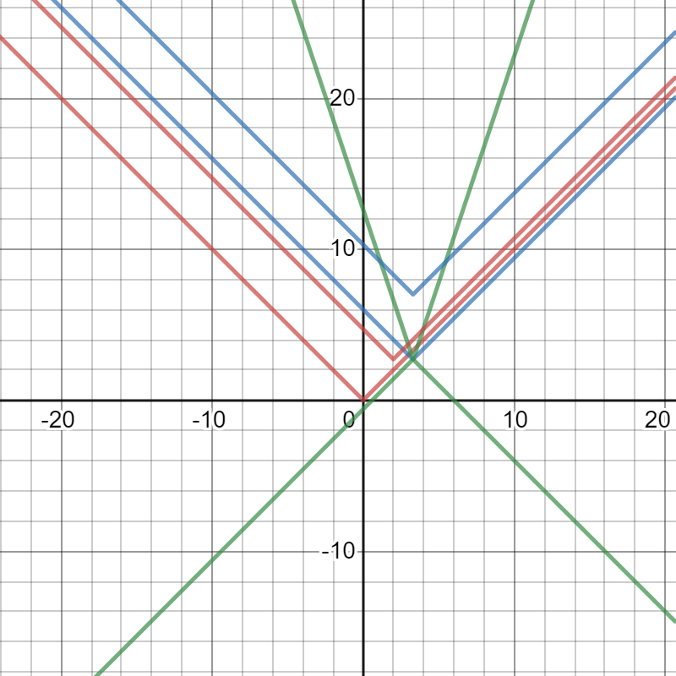

When AF is more than l1l, then there is a vertical stretch, if A is between 0 and 1, there is a vertical shrink. When A is negative, then the graph is reflected over y=d. When C is increased, the graph translates left, and decrease right. If d is increased, then the graph translates d units up, and d units down when it decreases.
The symmetric of the graph will be at the same point of the original graph
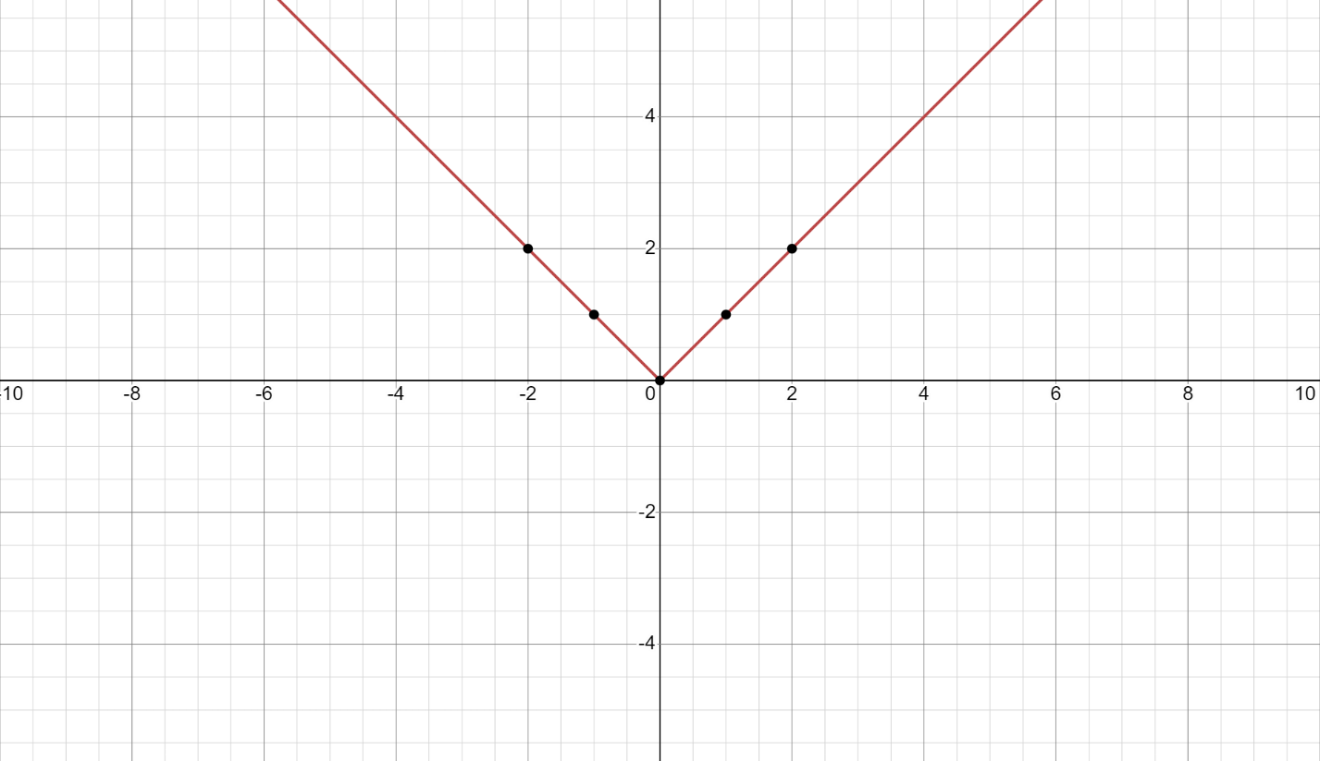

h. $f\left(x\right)=⟦x⟧$ (greatest integer less than x) [floor(x)]
Solution

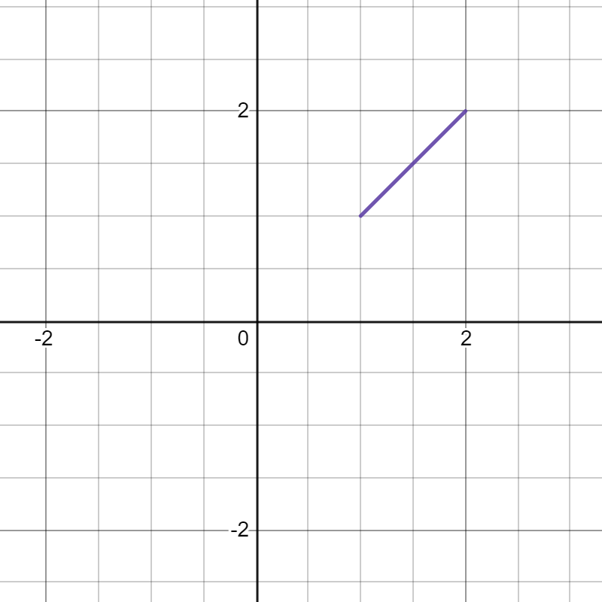
This is the original graph generated by the equation above.
Transformations
Having
y=af (b (x-c)) +d
a=-1
b=1
c=0
d=0
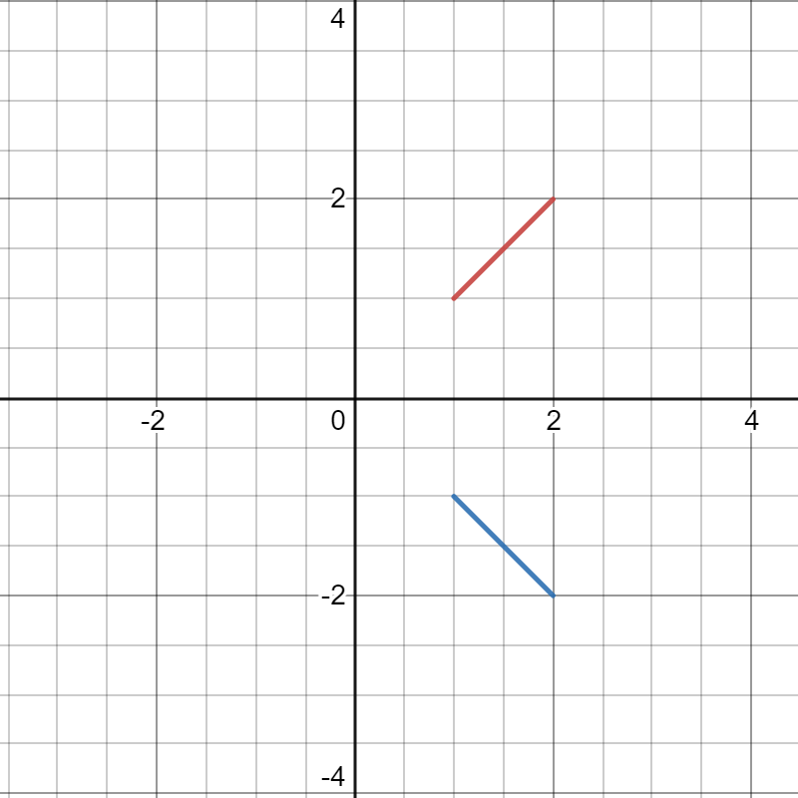
Having the (A = -1 and B = 1) the graph image is reflected on the opposite direction having the same but opposite co-ordinates. Having (c= 0 and d =0) the image starts the same point as the original one.

Letting
x=f(y)
We will have
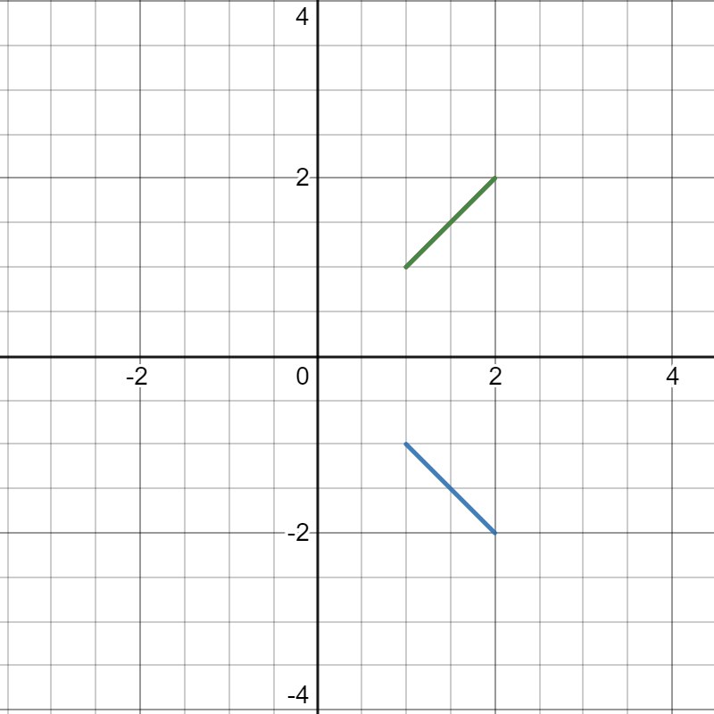
The graph image will be on the same position with the original one having the green color. Having no transformations
The asymmetric will be reflected 180 degrees

